
GROWING

ASPARAGUS

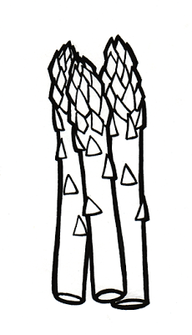

Where to grow
Asparagus prefers full sun and well-drained soil. Place in a site at the side or the end of the garden where the plants can grow and mature undisturbed. Asparagus plantings are perennial and will be in place for decades with proper care.
Planting
Dig or till liberal amounts of organic matter into the soil before planting.
- Create a trench 15” wide and 8” deep, throwing the soil off to the side.
- Place the crowns 1’ apart (the fleshy root system with buds) with the roots freely splayed out in the trench with the buds pointing up. At this point it is often recommended to cover the buds with 2” of soil.
- As the buds grow you continue gently covering them with the reserve soil until they have reached the top of the trench and are fully covered.
Care
Use a balanced vegetable garden fertilizer with high nitrogen levels (nitrogen is the first number in a 5-7-3 fertilizer, for example) at the time of planting either by incorporating into the soil before planting or applying on top of the soil. Fertilize annually after you’re finished harvesting. Water weekly the first year if we don’t have adequate rainfall.
Harvesting
As the plants mature the spears become larger. It is recommended that you wait to harvest any spears until the third season to allow the plants to develop heavy root systems. Harvest only for three weeks the first year. Thereafter, harvest from the time they appear in spring until late May or early June.
Remember these products for delicious results!
Earth-Friendly Fertilizers
- Espoma Garden Tone 3-4-4
- Dr. Earth Tomato, Vegetable & Herb 5-7-3
Amendments & Mulch
- Chalet Organic Compost 1 cu.ft.
- Cotton Burr Compost 2 cu.ft.
- Dehydrated Manure 40#
Insect Control
- Espoma Slug & Snail Control

